**ORB-SLAM: A Versatile and Accurate Monocular SLAM System**

**Abstract:**

This paper presents ORB-SLAM, a feature-based monocular SLAM system that operates in real time, in small and large indoor and outdoor environments. The system includes a survival of the fittest keyframe selection strategy and a new loop closing procedure that uses a covisibility graph and performs full bundle adjustment after loop closure. ORB-SLAM is built using only the ORB feature for all SLAM tasks: tracking, mapping, loop closing, and relocalization. We evaluate our system in the most popular public datasets and compare it with state-of-the-art monocular SLAM methods, showing improved accuracy and robustness. The system is released as open-source.

**Summary:**

**1. Objective:**

* To develop a **real-time**, **accurate**, and **robust** monocular SLAM (Simultaneous Localization and Mapping) system using only a single camera and a single feature type—**ORB (Oriented FAST and Rotated BRIEF)**.

**2. Key Contributions:**

* **Unified use of ORB features** for all SLAM components: tracking, mapping, relocalization, and loop closure.
* **Covisibility graph** and **Essential Graph** structures for efficient and consistent map optimization.
* **Survival of the fittest strategy** for keyframe management to maintain a compact yet rich map.
* **Loop closing** with similarity transformation and global bundle adjustment for accuracy and drift correction.

**3. System Components:**

* **Tracking**: Estimates camera pose by matching ORB features to the local map and maintains map integrity.
* **Local Mapping**: Maintains and updates a local map around the current frame. Adds new keyframes and performs local bundle adjustment.
* **Loop Closing**: Detects and corrects loops using place recognition (DBoW2), computes a similarity transform, and optimizes the pose graph.
* **Relocalization**: Highly reliable relocalization based on ORB feature matching and PnP pose estimation.

**4. Performance & Evaluation:**

* Tested on TUM RGB-D, KITTI, and New College datasets.
* Achieves state-of-the-art performance with higher accuracy than PTAM and LSD-SLAM.
* Operates in real time with only a monocular camera, handling large-scale and long-term SLAM tasks.

**5. Versatility:**

* Works across a variety of environments: small rooms, outdoor scenes, long trajectories, and revisited areas.
* Handles wide camera motions and illumination changes effectively.

**6. Open-source Impact:**

* The authors released ORB-SLAM as an open-source project, significantly contributing to academic research and practical applications in SLAM and robotics.

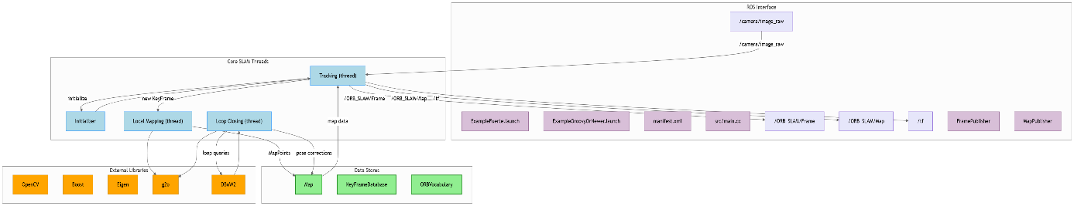

[**https://github.com/raulmur/orb_slam**](https://github.com/raulmur/orb_slam)

[**https://gitdiagram.com/raulmur/orb_slam**](https://gitdiagram.com/raulmur/orb_slam)

**ORB-SLAM2**

* An open-source SLAM system for monocular, stereo, and RGB-D cameras, building on the original ORB-SLAM framework.

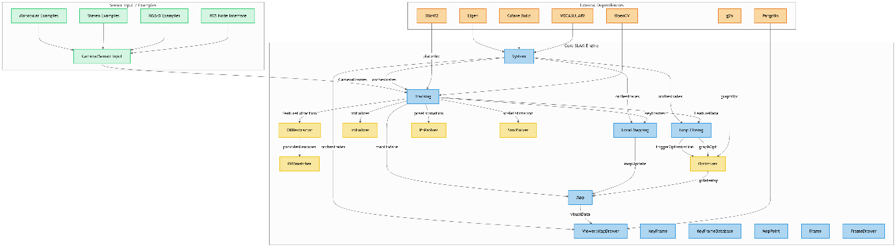

[**https://github.com/raulmur/ORB_SLAM2**](https://github.com/raulmur/ORB_SLAM2)

[**https://gitdiagram.com/raulmur/ORB_SLAM2**](https://gitdiagram.com/raulmur/ORB_SLAM2)

**AFE-ORB-SLAM: Robust Monocular VSLAM for Complex Lighting**

**Abstract:**

Visual SLAM systems often fail in environments with complex or changing lighting conditions due to unreliable feature detection and matching. To address this, we propose AFE-ORB-SLAM, an enhanced version of ORB-SLAM that integrates an Adaptive Feature Enhancement (AFE) module. This module improves the robustness of feature detection under variable lighting by adaptively adjusting image illumination and enhancing feature contrast. AFE-ORB-SLAM retains the original tracking, mapping, and loop closing structure of ORB-SLAM but significantly improves performance in challenging lighting conditions such as low light, overexposure, and dynamic illumination. Experimental results on public datasets and real-world scenarios show superior robustness and accuracy compared to standard ORB-SLAM.

Summary:

1. Objective:

* To improve the robustness of monocular visual SLAM (VSLAM) in challenging lighting conditions (e.g., low light, overexposed scenes, and dynamic illumination) by enhancing ORB-SLAM.

2. Key Contributions:

* Introduces an Adaptive Feature Enhancement (AFE) module, which:
  + Pre-processes the input frames to adjust brightness/contrast adaptively.
  + Enhances feature detectability and match reliability under varying lighting.
* Maintains the core architecture of ORB-SLAM, including:
  + ORB-based tracking
  + Local and global mapping
  + Loop closure
* Adds robustness without altering the foundational SLAM pipeline.

3. Methodology:

* AFE Module Workflow:
  + Input image undergoes adaptive enhancement using illumination-aware techniques (e.g., histogram equalization, CLAHE, or learning-based adjustment).
  + Enhanced images are fed into the ORB-SLAM pipeline for robust feature extraction.
* Ensures real-time performance by optimizing the computational cost of the AFE step.
* Keeps the feature extractor consistent (ORB), ensuring compatibility and easy integration.

4. Performance & Evaluation:

* Tested on public datasets (like EuRoC, TUM, and other custom indoor/outdoor sets with lighting variations).
* Demonstrates:
  + Reduced tracking failures in dark, bright, or flickering light scenes.
  + Improved feature match stability and relocalization accuracy.
* Outperforms original ORB-SLAM in metrics like Absolute Trajectory Error (ATE) and tracking success rate under poor lighting.

5. Advantages:

* Improves visual SLAM performance without requiring hardware changes or extra sensors.
* Adaptable to real-time applications such as AR, robotics, and UAV navigation.
* Enhances practical deployability of monocular SLAM systems in real-world scenarios.

6. Limitations:

* Slight increase in computational overhead due to the pre-processing step.
* Performance gains are lighting-dependent; may not benefit scenes that are already well-lit or uniform.

Conclusion:  
AFE-ORB-SLAM extends the capabilities of ORB-SLAM by incorporating adaptive pre-processing for feature enhancement, significantly boosting monocular SLAM performance in environments with complex lighting conditions—a critical step toward more robust real-world visual navigation systems.

[**https://github.com/sakshamjindal/Stereo-Visual-SLAM-Odometry**](https://github.com/sakshamjindal/Stereo-Visual-SLAM-Odometry)

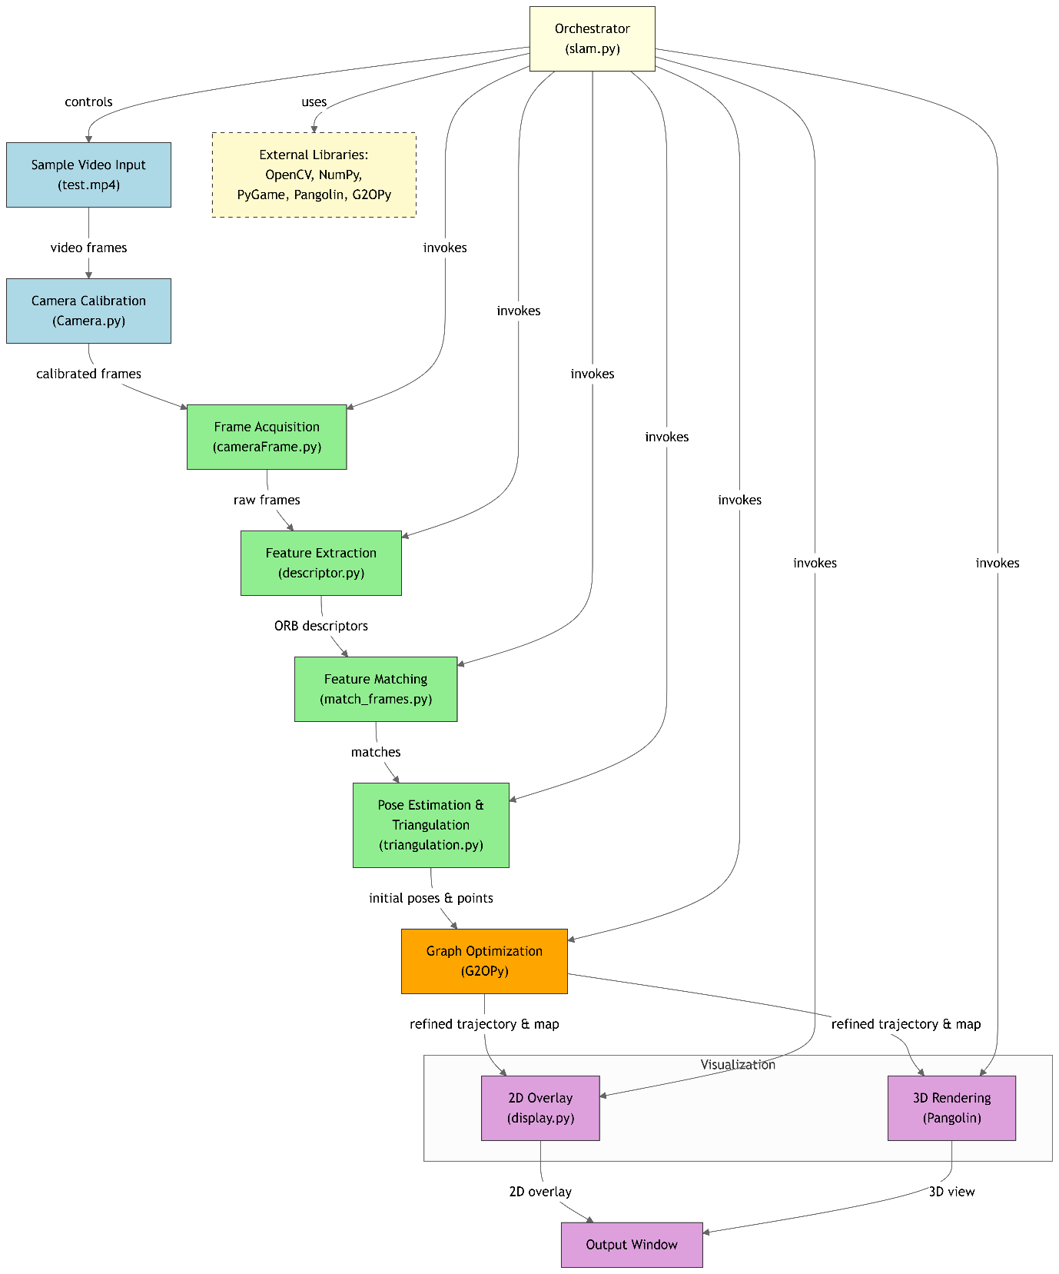

[**https://github.com/Akbonline/SLAMPy-Monocular-SLAM-implementation-in-Python**](https://github.com/Akbonline/SLAMPy-Monocular-SLAM-implementation-in-Python)

[**Visual-odometry-tutorial**](https://github.com/Taeyoung96/Visual-odometry-tutorial)

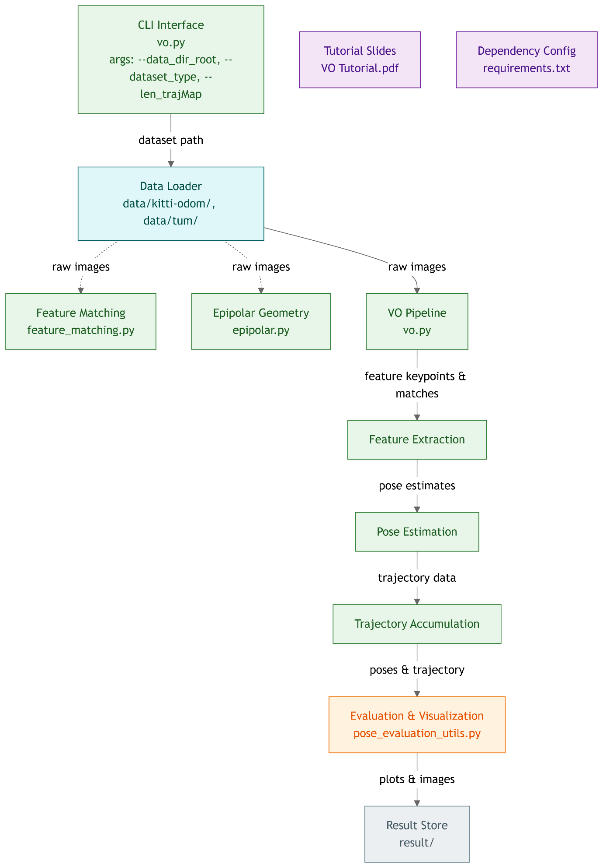

[**https://github.com/Taeyoung96/Visual-odometry-tutorial**](https://github.com/Taeyoung96/Visual-odometry-tutorial)

**Visual Odometry for Autonomous Vehicle Navigation**

**Abstract:**

Visual Odometry (VO) is a technique used to estimate the position and orientation (pose) of a vehicle by analyzing sequences of images captured by onboard cameras. In the context of autonomous vehicle navigation, VO serves as a critical component, especially in environments where GPS signals are unreliable or unavailable. By tracking visual features across consecutive frames, VO systems can infer the vehicle's motion over time, enabling real-time localization and navigation. This capability is essential for tasks such as path planning, obstacle avoidance, and map building in autonomous driving applications.

Summary:

1. Introduction to Visual Odometry:

* VO involves the process of determining a vehicle's motion by analyzing visual input from cameras. It estimates the vehicle's trajectory by detecting and tracking features across image sequences.

2. Importance of Autonomous Vehicles:

* In autonomous driving, accurate localization is paramount. VO provides a means to estimate vehicle motion without relying solely on external references like GPS, which can be unreliable in urban canyons, tunnels, or under dense foliage.

3. Methodologies:

* Monocular VO: Utilizes a single camera; challenges include scale ambiguity and sensitivity to lighting conditions.
* Stereo VO: Employs two cameras to perceive depth, providing more accurate scale estimation.
* Visual-Inertial Odometry (VIO): Combines visual data with inertial measurements from IMUs to enhance robustness and accuracy.

4. Applications:

* VO is integral to various autonomous vehicle functions, including:
  + Navigation: Determining the vehicle's path and position.
  + Mapping: Creating maps of the environment for path planning.
  + Obstacle Avoidance: Detecting and navigating around obstacles.

5. Challenges:

* VO systems face several challenges:
  + Lighting Variations: Changes in lighting can affect feature detection.
  + Textureless Environments: Lack of distinct features makes tracking difficult.
  + Dynamic Objects: Moving objects can introduce errors in motion estimation.
  + Computational Load: Real-time processing requires efficient algorithms.

6. Recent Advances:

* Research has focused on improving VO through:
  + Deep Learning: Leveraging neural networks for feature extraction and motion estimation.
  + Sensor Fusion: Integrating data from multiple sensors (e.g., LiDAR, radar) to enhance accuracy.
  + Robust Algorithms: Developing methods resilient to challenging conditions like rain or low light

7. Evaluation and Performance:

* VO systems are evaluated based on metrics such as:
  + Absolute Trajectory Error (ATE): Measures the difference between estimated and actual trajectories.
  + Relative Pose Error (RPE): Assesses the accuracy of motion estimation between frames.

Conclusion:

Visual Odometry is a vital technology for autonomous vehicle navigation, offering a means to estimate motion and position using visual inputs. While challenges remain, ongoing research and technological advancements continue to enhance the robustness and accuracy of VO systems, making them increasingly reliable for real-world autonomous driving applications.

**SVO: Fast Semi-Direct Monocular Visual Odometry**

**Abstract:**

This paper presents a novel method for fast and accurate visual odometry from monocular cameras. The proposed approach combines the advantages of direct methods, which minimize the photometric error to track the camera, and feature-based methods, which use geometric constraints for mapping. The result is a semi-direct method that tracks features at high frame rates and performs fast probabilistic depth estimation. The algorithm is designed for micro aerial vehicles, where robustness and computational efficiency are critical. Experiments show that our method outperforms state-of-the-art visual odometry methods in terms of speed while achieving competitive accuracy.

**Summary:**

**1. Objective:**

* To propose a **fast, robust, and accurate monocular visual odometry (VO)** method that can operate in real-time on lightweight platforms like **micro aerial vehicles (MAVs)**.

**2. Key Contributions:**

* Introduced **SVO (Semi-direct Visual Odometry)**—a hybrid method that combines the strengths of **direct methods** (which use pixel intensities) and **feature-based methods** (which rely on geometric features).
* Achieves **high frame-rate camera tracking** while maintaining robust and **probabilistic depth estimation**.

**3. Methodology:**

* **Tracking:** Uses a **direct image alignment** approach to track camera motion by minimizing **photometric error** across small patches centered on features. This avoids expensive descriptor computation and matching.
* **Mapping:** Performs fast **probabilistic depth filtering** of tracked features using a recursive Bayesian approach.
* Operates in a **semi-direct** way: it uses feature-like structures (e.g., image corners) for tracking, but instead of matching descriptors, it directly minimizes intensity errors.
* Depth estimation is **sparse**, leading to a lightweight map that supports fast computation.

**4. Performance & Applications:**

* Designed specifically for **onboard usage in MAVs**, where computational resources and latency are critical.
* Demonstrated to be **significantly faster than traditional feature-based methods** like PTAM and LSD-SLAM.
* Evaluated on public datasets (e.g., TUM RGB-D) and onboard a flying MAV in real environments.

**5. Advantages:**

* **Real-time operation** on standard CPU hardware.
* **Robust tracking** even in environments with little texture.
* **High frame rate** and **low latency**, making it suitable for fast-moving robotic platforms.

**6. Limitations:**

* As a VO system, **SVO does not perform loop closure** or global map optimization, so it can accumulate drift over long trajectories.
* Requires **initial motion** to bootstrap depth filters.

**Conclusion:**  
SVO is a **high-speed, semi-direct monocular VO system** that strikes a balance between accuracy and computational efficiency, making it ideal for real-time robotics applications like drone navigation.

<https://github.com/uzh-rpg/rpg_svo>

**Leveraging Deep Learning for Visual Odometry Using Optical Flow**

**Abstract:**

This paper explores deep learning approaches for monocular visual odometry (VO), aiming to replace traditional, highly engineered steps such as feature extraction and outlier rejection. The proposed architecture combines ego-motion estimation and sequence-based learning using deep neural networks. Camera motion is estimated from optical flow using Convolutional Neural Networks (CNNs), and motion dynamics are modeled using Recurrent Neural Networks (RNNs). The network outputs relative 6-DOF camera poses for a sequence and implicitly learns the absolute scale without requiring camera intrinsics. The entire trajectory is integrated without any post-calibration. The method is evaluated on the KITTI dataset and compared with traditional and other deep learning approaches in the literature.

Summary:

1. Objective:

* To develop a deep learning-based monocular visual odometry system that estimates camera motion using optical flow, eliminating the need for traditional feature extraction and matching processes.

2. Methodology:

* Optical Flow Estimation: Utilizes LiteFlowNet to compute dense optical flow between consecutive frames.
* CNN Architecture: A 7-layer CNN processes the optical flow to extract features relevant for motion estimation.
* RNN Integration: A bidirectional Long Short-Term Memory (LSTM) network models temporal dependencies and outputs relative 6-DOF poses.
* Scale Estimation: The network implicitly learns the absolute scale of motion without requiring camera intrinsic parameters.

3. Evaluation:

* Dataset: Tested on the KITTI odometry dataset.
* Comparisons: Benchmarked against traditional monocular VO methods (e.g., VISO) and deep learning approaches (e.g., MagicVO).
* Results: Demonstrated improved accuracy and robustness, particularly in challenging environments.

4. Advantages:

* Eliminates the need for camera calibration and post-processing steps.
* Reduces computational complexity by using fewer CNN layers and smaller LSTM networks compared to similar models.
* Enhances robustness to dynamic lighting and textureless environments.

5. Limitations:

* As with most monocular VO systems, it may still experience drift over long trajectories without loop closure mechanisms.
* Performance is dependent on the quality of optical flow estimation.

Conclusion:

The proposed deep learning framework effectively leverages optical flow for monocular visual odometry, balancing accuracy and computational efficiency. By integrating CNNs and RNNs, the system captures both spatial and temporal information, enabling accurate ego-motion estimation without the need for traditional VO components or camera calibration. This approach shows promise for applications in autonomous navigation and robotics, where real-time performance and adaptability to varying environments are crucial

**Visual Odometry Based on Stereo Image Sequences with RANSAC-Based Outlier Rejection Scheme**

**Abstract:**

This paper presents a novel approach for estimating vehicle egomotion using stereo image sequences. The method leverages trifocal geometry between image triplets, eliminating the need for time-consuming 3D scene reconstruction. An Iterated Sigma Point Kalman Filter (ISPKF) is employed alongside a RANSAC-based outlier rejection scheme to achieve robust frame-to-frame motion estimation, even in dynamic environments. The approach requires only knowledge of the camera geometry, which may vary over time. Evaluations using a high-accuracy inertial navigation system on challenging real-world video sequences demonstrate that the proposed method outperforms other filtering techniques in both accuracy and runtime.

Summary:

1. Objective:

* To develop a robust and efficient stereo visual odometry (VO) system capable of accurately estimating vehicle motion in dynamic environments without the need for full 3D scene reconstruction.

2. Methodology:

* Trifocal Tensor Utilization: The method relies on trifocal geometry, which relates features across three consecutive images, allowing for motion estimation without explicit 3D reconstruction.
* Iterated Sigma Point Kalman Filter (ISPKF): This filter addresses the non-linearities in the measurement equations, providing accurate state estimation.
* RANSAC-Based Outlier Rejection: A Random Sample Consensus (RANSAC) algorithm identifies and excludes outlier feature matches, such as those from independently moving objects, enhancing robustness.
* Feature Matching: The system requires only feature matches between consecutive stereo image frames, avoiding the need for long-term feature tracking.

3. Advantages:

* Robustness in Dynamic Environments: The combination of ISPKF and RANSAC ensures reliable motion estimation even when the scene contains moving objects.
* Efficiency: By avoiding full 3D reconstruction and long-term feature tracking, the method achieves real-time performance suitable for applications like autonomous driving.
* Flexibility: The approach accommodates varying camera geometries over time, making it adaptable to different hardware setups.

4. Evaluation:

* Experimental Setup: The system was tested on real-world video sequences, with ground truth provided by a high-accuracy inertial navigation system.
* Results: The proposed method demonstrated superior accuracy and runtime performance compared to other filtering techniques, validating its effectiveness for stereo visual odometry in dynamic scenarios.

Conclusion:

The presented stereo visual odometry approach effectively combines trifocal geometry, ISPKF, and RANSAC-based outlier rejection to achieve accurate and robust motion estimation without the need for full 3D reconstruction. Its efficiency and adaptability make it well-suited for real-time applications in dynamic environments, such as autonomous vehicle navigation.

**Flowdometry: An Optical Flow and Deep Learning Based Approach to Visual Odometry**

**Abstract:**

Visual odometry is a challenging task related to simultaneous localization and mapping that aims to generate a map traveled from a visual data stream. Based on one or two cameras, motion is estimated from features and pixel differences between frames. Because of the frame rate of the cameras, there are generally small, incremental changes between subsequent frames where optical flow can be assumed to be proportional to the physical distance moved by an egocentric reference, such as a camera on a vehicle. In this paper, a visual odometry system called Flowdometry is proposed based on optical flow and deep learning. Optical flow images are used as input to a convolutional neural network, which calculates a rotation and displacement for each image pixel. The displacements and rotations are applied incrementally to construct a map of where the camera has traveled. The proposed system is trained and tested on the KITTI visual odometry dataset, and accuracy is measured by the difference in distances between ground truth and predicted driving trajectories. Different convolutional neural network architecture configurations are tested for accuracy, and then results are compared to other state-of-the-art monocular odometry systems using the same dataset. The average translation error from the Flowdometry system is 10.77% and the average rotation error is 0.0623 degrees per meter. The total execution time of the system per optical flow frame is 0.633 seconds, which offers a 23.796x speedup over state-of-the-art methods using deep learning.

Summary:

1. Objective:

* To develop a visual odometry (VO) system, named Flowdometry, that leverages optical flow and deep learning to estimate camera motion efficiently and accurately.

2. Methodology:

* Optical Flow Computation: Utilizes FlowNetS, a convolutional neural network, to compute dense optical flow between consecutive frames.
* VO Estimation Network: A modified version of the contractive part of FlowNetS is employed to process the raw optical flow images and regress the camera's rotation and translation between frames.
* Input Representation: Unlike traditional methods that convert optical flow to color images, Flowdometry uses the raw two-channel optical flow (horizontal and vertical components) as input to the network.
* Training and Evaluation: The system is trained and tested on the KITTI visual odometry dataset, with performance measured against ground truth trajectories.

3. Results:

* Translation Error: Achieved an average translation error of 10.77%.
* Rotation Error: Recorded an average rotation error of 0.0623 degrees per meter.
* Execution Time: The system processes each optical flow frame in 0.633 seconds, offering a 23.796x speedup over other deep learning-based VO methods.

4. Advantages:

* Efficiency: Significantly faster than existing deep learning VO systems, making it suitable for real-time applications.
* Simplicity: By using raw optical flow as input, the system avoids additional preprocessing steps, simplifying the pipeline.
* Accuracy: Despite its simplicity and speed, Flowdometry maintains competitive accuracy in motion estimation.

5. Limitations:

* Error Accumulation: As with other inter-frame estimation methods, errors can accumulate over time, leading to drift in long sequences.
* Dependence on Optical Flow Quality: The accuracy of the VO estimation is heavily reliant on the quality of the computed optical flow.

Conclusion:

Flowdometry presents an efficient and effective approach to visual odometry by integrating optical flow and deep learning. Its design prioritizes speed and simplicity without compromising accuracy, making it a promising solution for applications requiring real-time motion estimation, such as autonomous driving and robotics.

